**ACTIVITY 1**

**TEAM OF 2 STUDENTS**

1. Open index.html on **Chrome**
2. Open “**script.js**” the javascript file, in VS Code, and read the content.
3. Follow the steps below and **submit** your script, **and your answers** to **google** **classroom** at the end.

**Q1 –** On the page, what happens when you click on the first “delete” button ?

**Q2 –** Here is the initial js code below.

* The function random simply generates a random number using the Math library
* The function rdnCol generates a random color like HTML understands, using the random function.

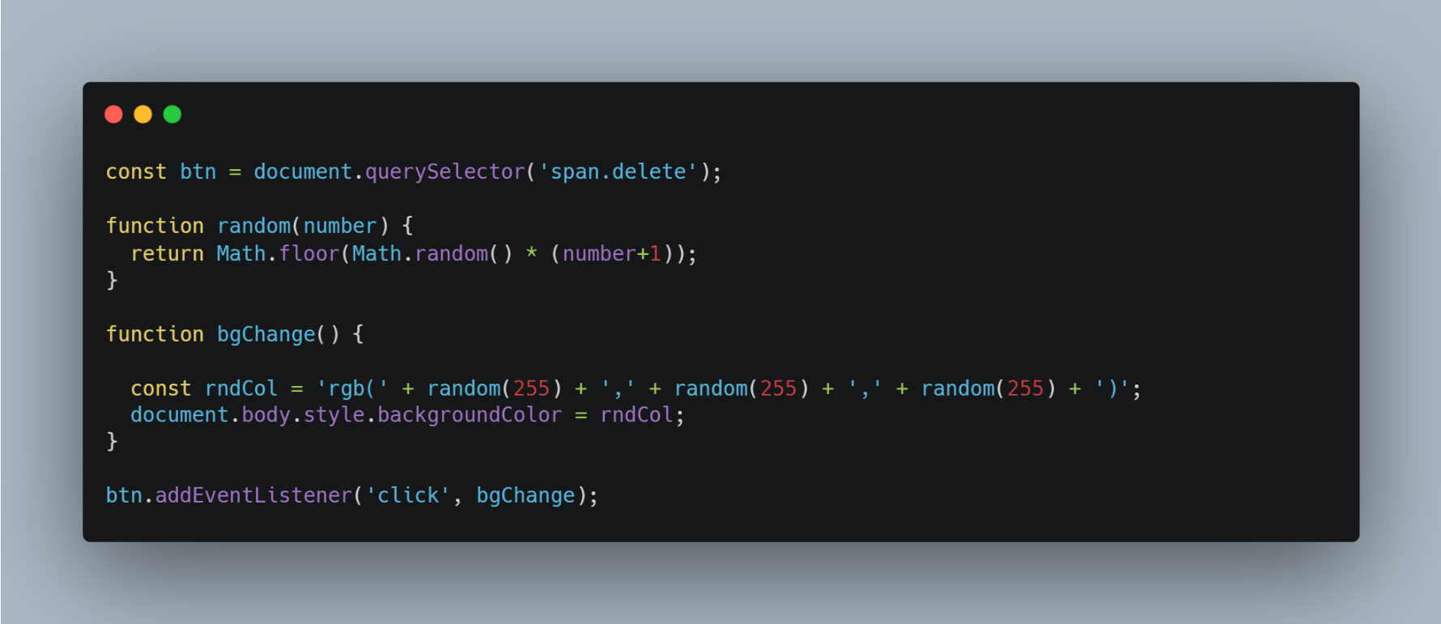

Which part of the code is used to get Elements from the page ?

**Q3 –** Which part of the code is used to create the Event listener ?

**Q4 –** Why is it only the first delete button that launches the event, and not all delete buttons ?

**Q5 –** Change the script so all delete buttons do the same as the first one. (When you click on any delete button, the color changes).